
COME & HELP US CELEBRATE
THE CHURCH’S 90TH BIRTHDAY!!!

This Photo by Unknown Author is licensed under CC BY-NC-ND

NEW HORIZONS CHRISTIAN CHURCH
(Fka: Meade Avenue Christian Church)
WILL BE CELEBRATING IT’S 90TH BIRTHDAY ON SUNDAY, SEPTEMBER 18TH, 2022,
BEGINNING WITH A WORSHIP SERVICE AT 10:45 FOLLOWED BY A FREE CHILI LUNCH!!
LOOKING FORWARD TO SEEING YOU AGAIN!!!!!!!
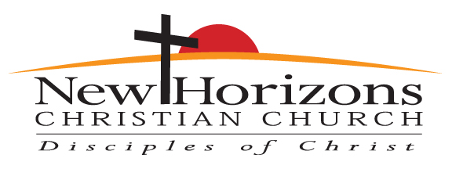

Statement of Calling
God is calling New Horizons Christian Church to follow Jesus by demonstrating Christian love, serving our neighbors, and growing with God

290 DARROW RD AKRON, OHIO 44305 (330) 733-3533

